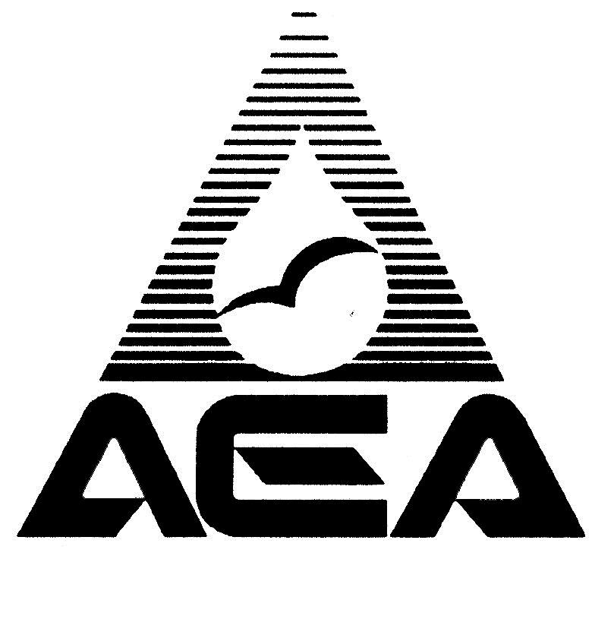

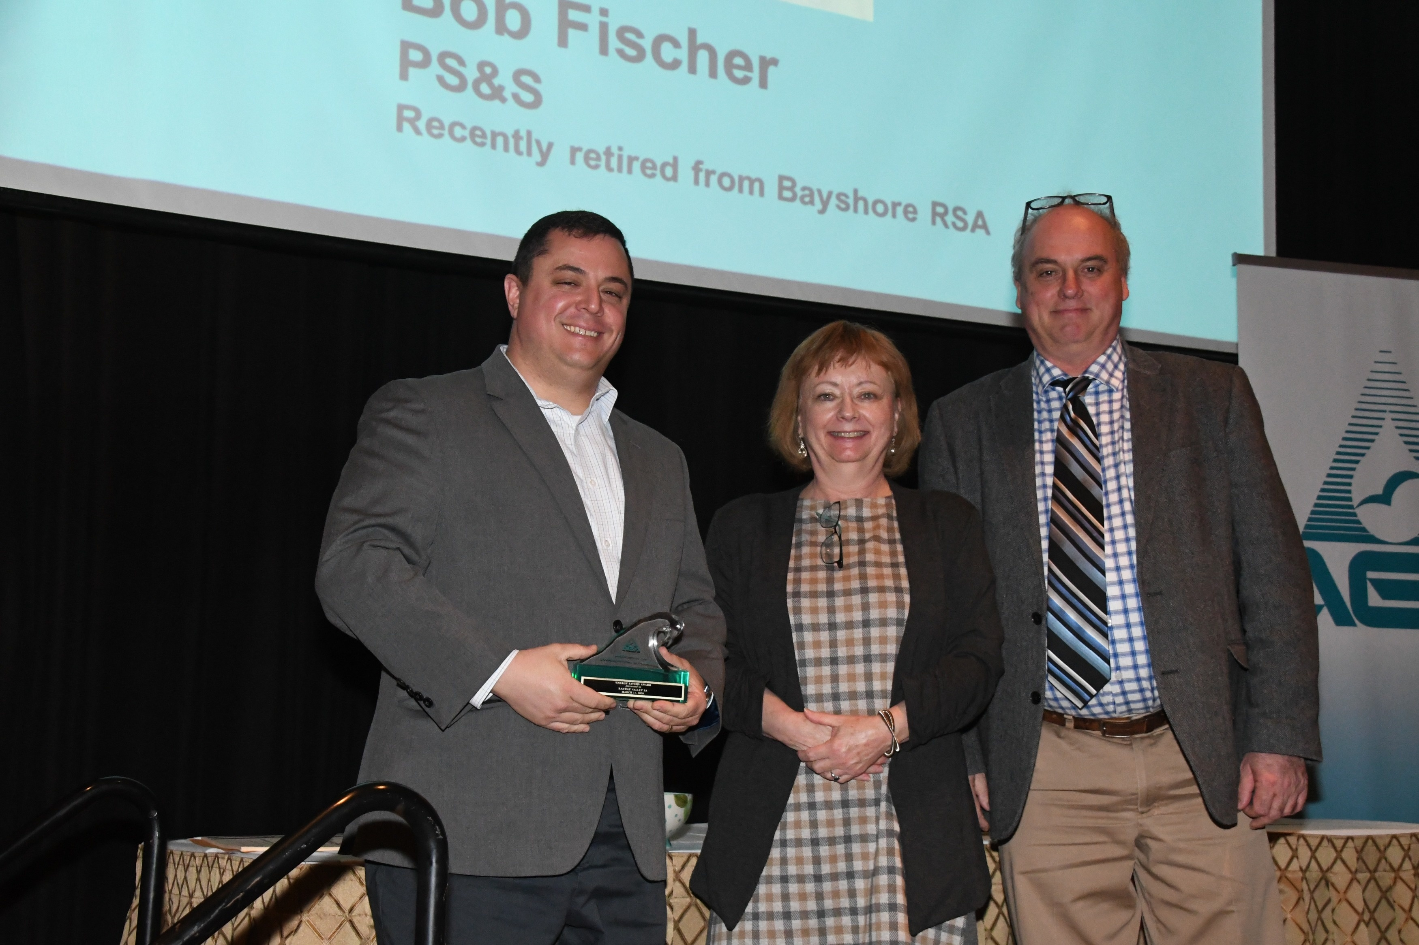

***Your Name Here***

**2021 Wave Awards**

Recognize Excellence!

**Nominations due Friday, Jan. 22, 2021**

*The Association of Environmental Authorities bestows Wave Awards to recognize excellence in the public water, wastewater, recycling, and solid waste sector in New Jersey. Submissions are reviewed by a three-member committee. The awards will be presented on Day Two, Wed., March 10, 2021 of the spring utility management conference.*

**Why Should I Submit a Nomination?**

Good work deserves attention. By submitting, you foster more success. You instill pride. You motivate. You help us raise awareness about the work we all do.

**How Do I Submit A Nomination?**

Complete the appropriate nomination form (see below). For each nomination, explain why the organization or individual award is merited. Include supporting documentation such as news stories, resumes, testimonial letters, or other material. Relevant project cost, savings attributed to an effort or project, descriptions of methodologies and other pertinent and distinguishing information should be included. Include photos or charts too, if applicable. Note: Certain limits on who can submit in some categories. See individual award type descriptions.

**Nominations are due Jan. 22, 2021**

Send the nomination via email (preferred method) to Karen Burris (karen@aeanj.org), by fax to 609-584-8271, or by postal mail, addressed to Karen, at the AEA offices, 2333 Whitehorse-Mercerville Road, Suite 2, Mercerville, 08619. For more information, contact Peggy or Karen.

**Award Descriptions**

**Up-and-Comer**

This award is aimed at helping cultivate association leadership and honor those who volunteer time and effort to AEA. The individual receiving this award is on the staff of a member organization and has, in the last three years, been consistently active and engaged in AEA, making a significant contribution to AEA and its members. Staff of regular and municipal member organizations eligible.

**Individual Achievement**

Recognizes extraordinary performance of duties of an operations or non-managerial staff member under difficult, adverse or challenging circumstances and/or recognizes skill and dedication. Ineligible: executive directors or department managers. Eligible: individual from regular and municipal member organizations.

**Mutual Aid Achievement Award**

Recognizes AEA regular or municipal member organization for outstanding or extraordinary effort to assist one or more member organizations during the past year. This awards celebrates the essence of AEA, because it is about banding together to face challenges and promote mutual interests.

**Wave Service Award**

Given to a non-member, individual who has gone to great lengths or effort over time to help AEA achieve its goals. This individual may be a regulator, a member of a local, state or federal legislative body or someone from any organization AEA works with in an on-going manner.

**Life Member**

Throughout AEAs history, there have been individuals from member organizations, who have devoted themselves to AEA, serving, volunteering and participating, and making outstanding contributions to AEA over time. Eligible individuals, from member organizations, may still be working in their profession or may be retired. The award permanently waives dues for the Lifetime Member upon their retirement, and it entitles them to attend AEA events. Lifetime Membership benefits do not accrue to the organization employing the honoree.

**Outstanding Commissioner Award**

This award will be given to a member of an authority board who:

Has served six years or more; embodies a “customer service ethic” by consistently acting in the best interests of ratepayers; has fostered positive relationships/mutual understanding between a regular/municipal member and its community or between the member organization and legislators; has supported AEA through active participation in AEA events; has offered outstanding leadership

*Nominees must be nominated by two other commissioners. Executive directors and professional consultants may not nominate commissioners.*

**Outstanding Associate Member, Individual**

This award goes to an individual employed by an associate member company, who has been active in AEA for more than 6 years and who has contributed in an exceptional manner to AEA through his or her committee work, by speaking or writing to inform and educate members in publications or at workshops and conferences, or who has supported AEA regulatory, legislative or public relations initiatives. Nominations can come from regular, municipal and associate members. But associate members may not nominate someone from their own company.

**Outstanding Associate Member, Organization.**

This award recognizes an AEA associate member organization that has been a member for six or more consecutive years and that has supported AEA through active participation in committees, as presenters, through sponsorships, contributing to AEA education efforts or in some way consistently supported AEA. Only AEA Board and Executive Committee members may submit nominations, and the recipient is chosen by the Executive Committee.

**Forward Thinking Award**

This award recognizes regular or municipal member innovation. It is presented to members that adopt successful new approaches or techniques in use of technology, facility design, or management. Authorities will submit applications for review by a selection committee.

**Public Education Award**

This award recognizes an outstanding public relations or public education efforts on the part of regular or municipal members. The efforts must promote understanding of the water, wastewater, solid waste or recycling industries, provide insight into the vital nature of AEA members’ services, or encourage vocational development in the environmental management field. Regular, municipal or associate members may submit nominations for this award.

**Best Management Practices Award**

This award goes to an authority/municipality that has implemented a process or program that addressed a need and resulted in measurable improvement in personnel management, consumables and inventory management, technical systems, facility operations and maintenance, performance measurement, security measures, customer service or energy. Regular and municipal members may make nominations in this category.

**Energy Savers Award**

This award recognizes good management and innovation in connection with energy. Success in saving energy costs or consumption, adopting innovation technology or managing energy use are the types of efforts recognized with this award.

**Association of Environmental Authorities**

**Wave Award Application**

**Deadline: Jan. 22, 2021**

*Select a category (Please use a separate entry form for each submission)*



**Name of Person and/or Member Organization Submitting Nomination**

_____________________________________________________________________________________

**Phone** __________________________________ **Email** ________________________________________

**Name of Organization Being Nominated**

_____________________________________________________________________________________

**Address**

_____________________________________________________________________________________

**Contact Person at Nominated Organization**

_____________________________________________________________________________________

**Phone** _____________________________**Email** _____________________________________________

**Fax** _______________________________________ (optional)

***(Continued)***

**Please use a separate sheet to answer the following questions that follow:**

1. Name or short description of project or program being nominated. *E.g. Main Street Pumping Station Redesign*
2. Describe the entry in detail including important and distinguishing details that make clear why the award is merited. Attach any examples, samples, photos, etc. which relate to this entry. Answer the following questions:

* What was the approximate budget and source of funding?
* Why was the program, project, etc. being prepared or done? What was the goal?
* What obstacles needed to be overcome?
* Was the goal achieved?
* What was the benefit to the authority/company/community?

**Association of Environmental Authorities**

**Wave Award Application**

**Deadline: Jan. 22, 2021**

*This form can be used for any of the awards listed. You must fill out one of these forms for each nomination. Please indicate which award this nomination is being submitted for.*

|  |  |  |  |
| --- | --- | --- | --- |
|  | **Up-and-Comer Award** |  | **Outstanding Associate Member, Individual** |
|  | **Individual Wave Achievement** |  | **Outstanding Commissioner** |
|  | **Mutual Aid Wave Achievement** |  | **Associate Member of the Year** |
|  | **Outstanding Associate Member, Organization** |  | **Lifetime Member** |
|  | **Wave Service** |  |  |

**Name of Nominee**______________________________________________________________________

**Affiliation**_____________________________________________________________________________

**Address** ______________________________________________________________________________

**Principal/Officer of Company**_____________________________________________________________

**Phone** _______________________________________________________________________________

**Email** ________________________________________________________________________________

**Fax**________________________________ *(optional)*

**Reasons for nominating this person.**

(Use a separate sheet of paper. All entries must include the following information):

• Nominee’s involvement in AEA; years of membership

• Description of activities they performed to merit the award

• What personal qualities does the nominee have which enhances his/her professionalism?

*Please add any newspaper articles, stories or background material which are appropriate.*

**Signature of person(s) making the nomination (2 required for Commissioners Award)**

________________________________________ ____________________________________

(Signature) (Signature)

___________________________________________ ______________________________________

(Print Name of Above) (Print Name of Above)

**Affiliation**____________________________________________________________________________

**Address**______________________________________________________________________________

**Phone**________________________**Email**___________________________________________________

**Fax**____________________________ (optional)